Right Shift Operator

It requires two operands. It shifts each bit in its left operand to the right. The number of places the bits are shifted depends on the number I.e. its right operand.
As the bits are shifted to the right ,blanks are created on the left. These blanks must be filled somehow. They are always filled with zeros.

64 >> 1 gives 32
(1000000) (100000)
64 >> 2 gives 16
i.e.
64 >> 1 is equivalent of
64/2¹
64 >> 2 is equivalent of
64/2²

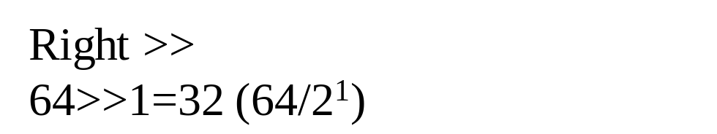

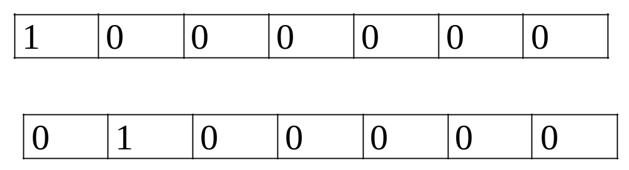

Left Shift Operator

Bits are shifted to the left and for each bit shifted a zero is added to the right of a number
64 << 1 gives 128
(1000000) (10000000)
i.e.
64 << 1 is
64 * 2¹

